**Curriculum pathway:**

**Key Vocabulary:**

Absorb - to suck up or soak up light waves

Refract - when light changes direction, or bends

Prism - a piece of glass or other transparent material useful for analysing and reflecting light

Lens - a piece of glass or other see-through material that is curved on one or both sides

Ray - the straight-line paths followed by narrow beams of light

Beam - a small projection of light energy coming from a source

Focal point - the point in space where parallel light rays meet after passing through the lens

Blood vessel - a tube that carries the blood throughout the body

Circulatory system - blood vessels that carry blood away from and towards the heart

Plasma - a yellowish fluid that has nutrients, proteins, hormones, and waste products

Platelets - tiny blood cells that help your body form clots to stop bleeding

**Science Year 6**

**Autumn Term – Fighting Fit**

**Light**

**Animals including humans**

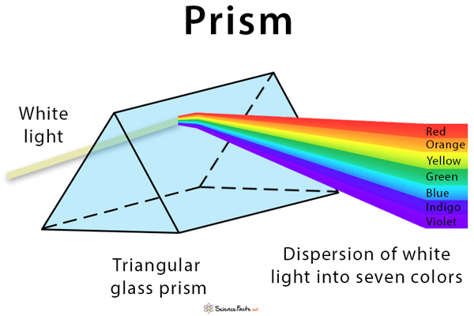

**Key Questions:**

**Animals including humans**

What is the circulatory system?

How does diet effect growth?

Are all drugs bad for you?

How is water used within the body?

What is blood made of?

What are the main organs within the human body?

What are the main systems of the human body?

**Key Questions:**

**Light**

How does light travel?

How do we see things?

What do mirrors do to light?

How do we see colours?

Why do shadows have the same shape as the object that casts them?

**Key Facts:**

Light travels slower through different materials like water and glass.

We see different colours because each colour has its own wavelength.

InfraRed rays are invisible to humans.

Light travels nearly 900,000 times faster than sound.

A prism splits a beam of light into the colours of the visible spectrum.

The heart beats 2.5 billion times during the life of a 75-year-old.

Blood is a mixture of fluid, plasma, white and red blood cells.

Red blood cells transport oxygen to every cell and remove carbon dioxide.