**Curriculum pathway:**

**Key Vocabulary:**

Dissolve - when a substance is mixed with water to make a transparent (see-through) liquid called a solution

Insoluble - does not dissolve in water

Chemical - a substance that has specific properties or characteristics we can use to identify it.

Solution - a mixture of two or more substances that stays evenly mixed.

Permeable - having pores or openings that permit liquids or gases to pass through

Soluble - it can be dissolved in liquid

Resistance - a force that opposes or slows down another force.

Filter - a device used to remove unwanted parts from something

Sieve - a device with meshes or holes to separate finer particles from coarser ones or solids from liquids

Gestation period – The time from fertilisation to birth

Asexual - to self-fertilise to make offspring

Cell - the smallest unit with the basic properties of life

Embryo - the name given to an unborn baby from the time of fertilization until eight weeks of development

**Science Year 5**

**Summer Term – The Industrial Age**

**Properties and changes of materials**

**Living things and habitats**

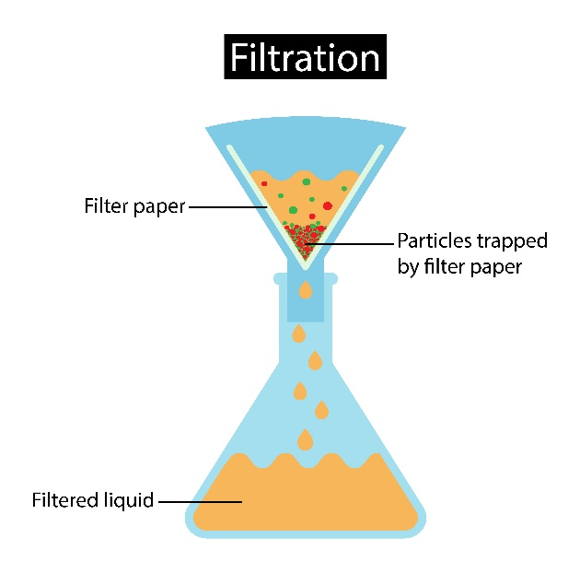

**Key Facts:**

The most common example of filtering is making a cup of tea.

The material with the highest known melting temperature is a metal called tungsten which melts at 3387 degrees Celsius.

Burning is an irreversible chemical change.

The ostrich lays the biggest eggs of any land animal.

A small number of animals are asexual which means they can self-fertilise.

Elephants have the longest gestation period of all mammals, carrying their babies for almost two years (22 months).

**Key Questions:**

What are thermal conductors and insulators and why are they used?

Which electrical conductors makes a bulb shine the brightest?

What is the difference between melting and dissolving?

What is the difference between sexual and asexual reproduction?

What are the three different types of mammals?