**Curriculum pathway:**

**Key Vocabulary:**

Evolution - the way that living things change over time

Adaptation - special body parts or behaviours that help a living thing survive in an environment

Inherited traits - your physical characteristics, like your hair or eye colour.

Inheritance - when living things reproduce they pass on characteristics to their offspring

Adaptive traits - a characteristic of a living thing that helps it survive in its environment

Natural selection - a mechanism of evolution

DNA - the genetic information inside the body's cells that helps make people who they are

Genes - they carry the information that determines your traits inherited from your parents.

Variation - The differences in characteristics between individuals of the same species

Micro-organism - a living thing that is too small to be seen with the naked eye

Taxonomy - the process of organising living things into groups that have common characteristics

**Science Year 6**

**Summer Term – Back to our Roots**

**Evolution and Inheritance**

**Living Things and Their Habitats**

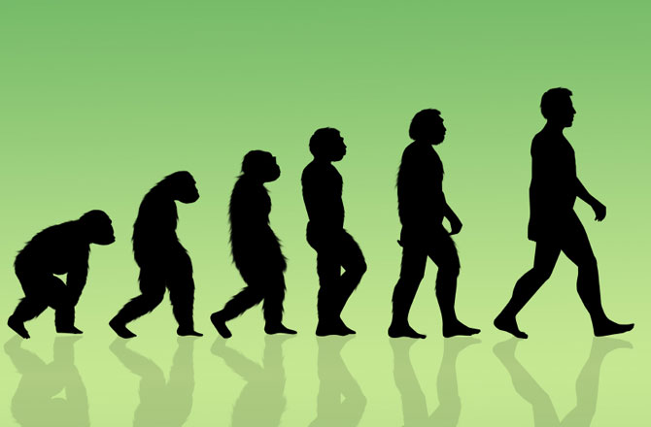

**Key Facts:**

All living things have a common ancestor – a bacterium that lived billions of years ago.

The closest living relation of birds is the crocodile.

Darwin said that monkeys, apes and humans had a common ancestor.

Humans, unlike other animals, have opposable thumbs making it easier for us to pick things up and hold things.

Up until 10,000 years ago, all humans had brown eyes.

Microorganisms are found in almost every habitat present in nature.

**Key Questions:**

Who was Charles Darwin/Mary Anning?

How are fossils formed and how long (on average do they take to form?

Are inherited characteristics always physical?

What is the difference between inherited and acquired characteristics?

How do animals and plants adapt to their environment?

How could adaptation lead to evolution?

What is a fungus?