**Curriculum pathway:**

**Key Vocabulary:**

Material – What something is made from

Properties - the characteristics that enable us to differentiate one material from another

Sprout – A shoot of a plant

**Science Year 2**

**Spring Term – My Country, My City**

**Materials**

**Plants**

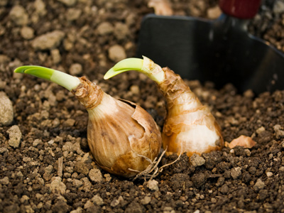

**Key Facts:**

Seeds need to wait for conditions to be just right before they start to grow.

Bulbs can sprout new growth.

**Key Questions:**

What materials are strong?

What materials are weak?

How are bulbs different from seeds?