**Curriculum pathway:**

**Key Vocabulary:**

Gravity - an invisible force that pulls objects towards each other

Air resistance - a kind of friction that occurs between air and another object

Water resistance - a type of force that uses friction to slow things down that are moving through water

Buoyancy - an objects ability to float in water and air

Friction - a force between to surfaces that are trying to slide across each other

Lever - machine used to create force

Gear - wheels with teeth that slot together

Cog - a tooth on the rim of a wheel or gear

Pulley - a wheel that carries a flexible rope, cord, cable, chain or belt on its rim

Puberty - the period of time when a body transitions from child to adult

Foetus - an unborn baby that grows and develops inside the uterus

Fertilisation - the joining of an egg and a sperm

Adolescence - phase of life between childhood and adulthood

**Science Year 5**

**Spring Term – Beautiful Britain**

**Forces**

**Animals including humans**

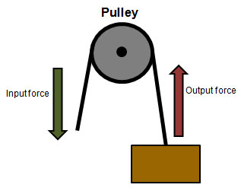

**Key Facts:**

Gravity keeps the Earth and all the planets in our solar system in orbit around the Sun.

A ship floats on water because the force from the water pushing it up is equal to the force pulling it down.

Forces are measured in newtons (N) using a newton meter, named after Sir Isaac Newton.

Human beings always grow more brain cells than they need this enables mental development in old age to continue.

Some animals go through metamorphosis where they change into a very different animal.

**Key Questions:**

What is the effect of gravity on unsupported objects?

How does air resistance affect moving objects?

How can you minimise the effect of water resistance on objects?

What is the purpose of a lever?

What are the 6 different stages of human development, in order?

What are the main changes that occur during puberty?

What are the main changes that take place during old age?