St Mary’s & St Peter’s Catholic Primary School
LONG TERM PLANNING – Yr 4
 | Autumn | Spring | Summer
Topic | Our Magical City | The Great Fire of London | The Great Escape
R.E | Aut 1 : Judaism – Beliefs and practices  Aut 2 : Christianity – Christmas/ Incarnation | Spr 1: Judaism – Passover  Spr 2: Christianity – Easter/ Salvation | Sum 1: Judaism- Rites of Passage and good works  Sum 2: Christianity – Prayer and worship
Oracy opportunities | Skills: active listening, taking turns, sharing ideas, building on, sensing the room, joining in  Roles: Observer, Scribe | Skills: inviting others, making notes, using speech bubbles, asking questions, agreeing and disagreeing  Roles: Challenger, Reporter | Oracy games:  ABCD  Line of agreement  Snowballing  True or false
Science | States of Matter | Electricity  Living things and their habitats | Animals including humans  Sound
PSHE/RSE | What makes a balanced lifestyle and making choices; drugs common to everyday life: hygiene and germs  How to keep safe in the local area and on line; people who help them stay healthy and safe. | God loves us in our differences | Sustainability of the environment across the world  Role of money, managing money what is meant by interest and loan  One plastic bag – link to rethink foods
English Texts | Aut 1:  English: Oliver Twist – Charles Dickins  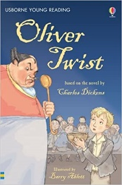  English: Oliver Twist – Charles Dickins  Guided Reading: Leather Shoe Charlie  Class Reader: The Secret History of Tom Trueheart by Ian Beck  Aut 2:  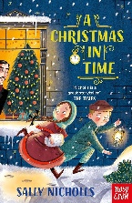  English: A Christmas in time by Sally Nicholls  Guided Reading: The Rhythm of the Rain  Class Reader: Alex Neptune: Dragon thief by David Owen | 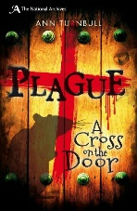  Spr 1:  English: Plague (National Archives) by Ann Turnbull  Guided Reading: Plague: A History of Pestilence and Pandemics  Class Reader: The girl who walked on air by Emma Carroll  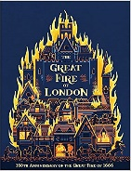  Spr 2:  English: The Great Fire of London by Emma Adams  Guided Reading: The Great Fire: A City of Flames  Class Reader: Shipwrecked by Jenny Pearson | 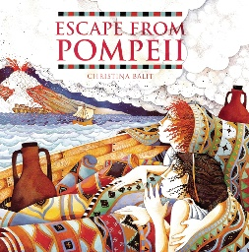  Sum 1:  English: Escape from Pompeii by Christina Balit  Guided Reading: How things happen in the Natural World  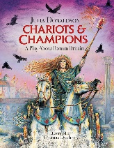  Class Reader: Journey to the river sea by Eva Ibbotson  Sum 2:  English: Chariots & Champions by Julia Donaldson  Guided Reading: You Wouldn’t want to be a Roman Solider  Class Reader: Journey to the river sea by Eva Ibbotson
Maths | Chapter 1 - Numbers to 10,000  Chapter 2 - Addition and Subtraction within 10,000  Chapter 3 - Multiplication and Division  Chapter 4 - Further Multiplication and Division | Chapter 4 - Further Multiplication and Division  Chapter 5 - Graphs  Chapter 6 – Fractions  Chapter 7 - Time  Chapter 8 - Decimals | Chapter 9 - Money  Chapter 10 - Mass/ Volume/ Length  Chapter 11 - Areas of figures  Chapter 12 - Geometry  Chapter 13 - Position & Movement  Chapter 14 - Roman Numerals
Computing | Computer Science  Information Literacy  Online Safety | Media  Data Handling  Online Safety | Computer Science  Media  Online Safety
P.E | Football  Gymnastics | Dance  OAA | Cricket  Athletics
Art | Well known Artist – Hockney | Paul Klee abstract art | Michael Angelo – pastels, sculpture  Mosaics
DT | Making a mascot pneumatics | Make an electrical switch | Jewellery from plastic bags/plastic
History | Saltaire/ local history | The Great Fire of London | Romans – Impact on Britain, Romanisation of Britain
Geography | Settlements/land use  Canals |  | Rome – city in Europe, compare and contrast with Bradford, Volcanoes
Spanish | Colours revised  Parts of the body  Zoo animals  Christmas Spanish songs | Members of the family  Asking and answering questions  Pets | Hobbies  Numbers 13 – 30  Items of clothing  Means of transport
Music Tuition | Ukulele | Ukulele | Ukulele
Music | Mamma Mia  Glockenspiel stage 2 | Stop!  Lean on me | Blackbird  Reflect, Rewind and Replay
Experiences | History - Now Press Play Victorian Britain  Art – seeing the arrival of spring at Salts Mill  History – visiting Saltaire village | History - Now Press Play – Great Fire of London | Rethink food Summer 1  SDG – industry, innovation and infrastructure, decent work and economic growth, Reduced inequalities.  History - Now Press Play – Roman Britain
Opportunities for Outdoor Learning | History - Visit Saltaire – walking tour  Science – making solids, liquids and gases | Science – classifying minibeast in school grounds  History - Bolling Hall – Great fire of London workshop | History - Murton Park – Roman day
Opportunities for Aspirations | PSHE – jobs public services  Art– local artist from Yorkshire  Spanish – learn another language  Music - become a singer/musician | DT – jobs designer/engineer  History – job fight fighter to teach how to put out fires  Spanish – learn another language | PHSE – environmentalist  Spanish – learn another language  Music –become a ukulelist
Opportunities for Healthy Lifestyles/Nutrition | History - Nutrition cooking lessons – making food from the Victorian era  PE - Healthy lifestyles – physical, active lesson  PSHE - having a balanced diet | PE - Healthy lifestyles – physical, active lesson | Nutrition lessons – making food from the Romans  PE - Healthy lifestyles – physical, active lesson  Science – looking after teeth

