Coop Academy Penny Oaks
LONG TERM PLANNING – Year 3
 | Autumn | Spring | Summer
Topic | Who first lived in Britain?  Stone Age | Here there and Everywhere | Groovy Greeks
R.E | Divali  Christmas | Jesus’ Miracles  Easter- Forgiveness | Hindu Beliefs  Pilgrimage to the River Ganges
Science | Plants  Rocks | Animals including humans  Plants | Plants  Light  Forces and magnets
Oracy | Autumn 1:  Cognitive: I can add an idea to someone else’s  Linguistic: I choose my words carefully  Social and emotional: I can make sure everyone gets a chance to speak  Physical: I can speak in a loud clear voice  Autumn 2:  Cognitive: I can say why I think something  Linguistic: I always speak in sentences that make sense  Social and emotional: I can take turns  Physical: I will look at the person who is speaking | Spring 1:  Cognitive: I can talk about the main points  Linguistic: I understand who I am talking to  Social and emotional: I am confident in what I am saying  Physical: I can speak at a steady pace  Spring 2:  Cognitive: I can agree or disagree with others  Linguistic: The words I choose entertain people  Social and emotional: I will be excited to share ideas  Physical: You can hear me when I speak | Summer 1:  Cognitive: I can think of a question to as to make sure I understand  Linguistic: I can use all 4 linguistic talk rules  Social and emotional: I will give 5 to the person who is speaking  Physical: I will sit/stand tall when I speak  Summer 2:  Cognitive: I can sequence my thoughts before I speak  Linguistic: I can use all 4 linguistic talk rules  Social and emotional: I will think how what we say can affect others feelings  Physical: I can make my voice sound interesting
PSHE/RSE | Coop Values  Meet your brain  Keeping Safe  The Story Project:  On a Magical Do Nothing Day  Ossiri and The Bala Mengro | Celebrate  Appreciate  Health & Wellbeing  The Story Project:  The Hundred Dresses  Ruby’s Worry | Relate  Families  Engage  Pants  The Story Project:  Faruq and the Wiri Wiri  No Money Day
English Texts | Autumn 1:  The First Drawing (Persuasive Letter)  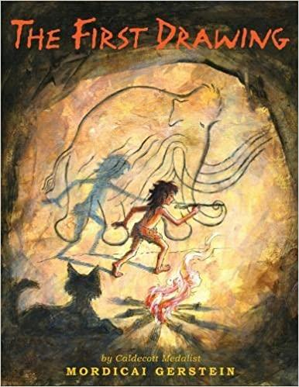  Stone Girl Bone Girl (Biography)  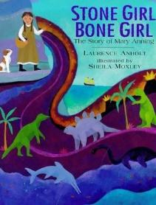  Guided Reading: The pebble in my pocket; DK findout stone age  Class Reader: The Wild Way Home  Autumn 2:  Iqbal and his Ingenious Idea (Explanation Text)  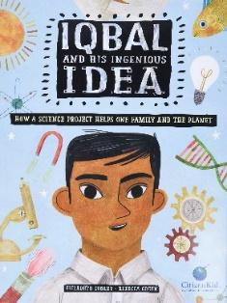  A Christmas carol (Setting Description)  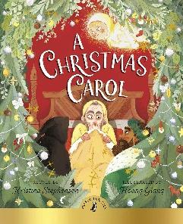  Guided reading: Habitat Destruction | Spring 1:  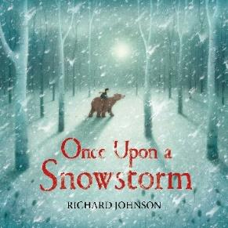  Once Upon a Snow Storm (Show not tell)  Emmanuel’s Dream (Newspaper Article)  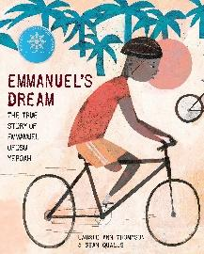  Guided Reading: The Blue House, Enzo’s Egg  Class Reader: The Breakfast Club Adventures: The Beast Beyond the Fence  Spring 2:  There’s a Rang-Tan in my Bedroom (speech)  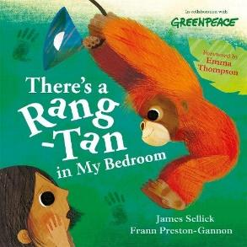  Guided Reading: Greta and the Giants | Summer 1:  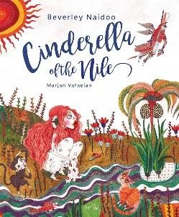  Cinderella of the Nile (Alternative Fairy Tale)  Guided Reading: Revolting Rhymes  Class Reader: Who Let the Gods Out?  Summer 2 :  Herakles early myths (Greek Myth)  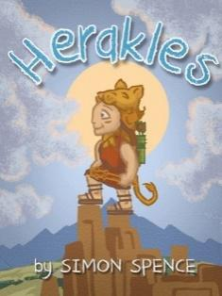  Guided Reading: Myths & Mayhem in Ancient Greece
Maths | Chapter 1 - Numbers to 1000  Chapter 2 - Addition & Subtraction  Chapter 3 & 4 - Multiplication & Division | Chapter 5 - Length  Chapter 6 - Mass  Chapter 7 – Volume  Chapter 11 - Fractions | Chapter 8 - Money  Chapter 9 - Time  Chapter 10 - Picture graphs  Chapter 12 - Angles  Chapter 13 - Lines of Shapes  Chapter 14 - Perimeter of figures
Computing | Computer Science  Information Literacy  Online Safety | Media  Data Handling  Online Safety | Computer Science  Media  Online Safety
P.E | Hockey & Football  Gymnastics | Dance  OAA | Badminton & Volleyball  Athletics
Art | Stone age art  Ismael Gulgee | Linda MacKey – Arctic Art | Greek pottery
DT | Page for a pop-up book | Badges | Fajitas/Pitta
History | Britain from the stone age to the iron age |  | Ancient Greece
Geography | Effects of human activities on the UK’s landscape | Latitude and Longitude  Biomes | European Country Study (Greece)
Spanish | A New Start  Greetings, feelings, numbers to 10 & colours  Calendar and Celebrations  Colours, classroom commands, days and months, Christmas | Animals I like and don’t like  Animal nouns, singular and plural, opinions  Carnival and using numbers  Carnival, numbers to 15, core language recap, age, dates, Easter | Fruits and vegetables  Fruit and veg nouns, counting, asking politely  Going on a picnic  Food items, Polite requests  Aliens in Spain  Explore Spain, ask and answer “Where do you live?”
Music Tuition | Ukulele | Ukulele | Ukulele
Experiences | *Rethink food (Autumn 2)  SDGs:  Affordable and Clean Energy  Sustainable Cities and Communities  Now Press Play Stone Age  Now Press Play Rocks | Science - plan and cook a meal | Now Press Play Ancient Greece  History – Visit a library (50 things)  Science – shadow puppets (50 things)  Greek day – dress in Greek clothing, eat Greek food, set up Greek style classroom.
Opportunities for Outdoor Learning | Cliffe Castle – Rocks & Fossils and stone age workshop  Science – Rock hunt | Science – growing plants | Leeds Museum – Ancient Greece workshop  Geography – walk around Bradford
Opportunities for Aspirations | Mary Anning (Female Scientist) | Linda McKay (Female Artist)  Greta Thunberg (Young, Female activist)
Opportunities for Healthy Lifestyles/Nutrition |  | Science – nutrition

