Co-op Academy Penny Oaks
LONG TERM PLANNING – Year 5
 | Autumn | Spring | Summer
Topic | Adventures | Beautiful Britain | The Industrial Age
R.E | Belief into action  Christmas | Beliefs and moral values  Easter | Prayer and Worship  Beliefs and Practices
Oracy | Recap on all cognitive, linguistic, social, emotional and physical talk rules  Apply/refer to talk rules accordingly during presentations, discussions, debates and when asking and answering questions | Recap on all cognitive, linguistic, social, emotional and physical talk rules  Apply/refer to talk rules accordingly during presentations, discussions, debates and when asking and answering questions | Recap on all cognitive, linguistic, social, emotional and physical talk rules  Apply/refer to talk rules accordingly during presentations, discussions, debates and when asking and answering questions
Science | Earth & Space | Forces  Animals including humans | Properties and changes of materials  Living things and habitats
PSHE/RSE | Co-op Values - Equality  Meet My Brain  The Story Project | Celebrate  Appreciate  The Story Project | Relate  Engage  The Story Project
English Texts | Autumn 1:  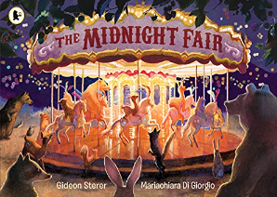  The Midnight Fair: Newspaper report  Hidden Figures: Autobiography  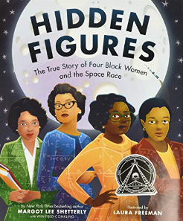  Guided Reading: Everest, Counting on Catherine  Class Reader: Space Oddity  Autumn 2:  English: The Wind in the Wall: Gothic narrative  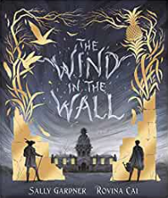  The Polar Express: poetry  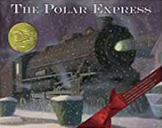  Guided Reading: Atlas of Adventures  Class Reader: Can you see me? | Spring 1:  The really useful guide to Kings and Queens of England: Non-chronological report  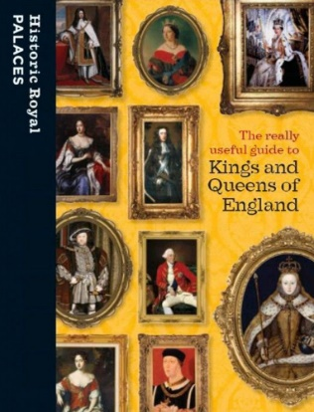  Henry VIIIs Secret Diary: Recount diary entry  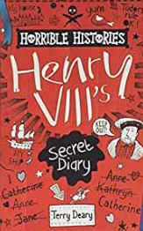  Guided Reading: Little Elizabeth  Class reader: The Fart that Changed the World  Spring 2:  The Lost Words: Poetry and discussion text  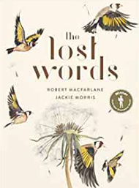  Guided Reading: What a Waste, Beautiful Britain  Class Reader: Holes | Summer 1:  The Last Wild: Character and Setting description  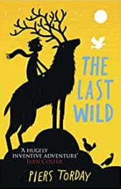  Guided reading: Investigating the Victorians, Varmints  Class reader: The Vanishing Trick  Summer 2:  The Story of Harvey Milk and the Rainbow Flag (PSHE): instructions and radio advert  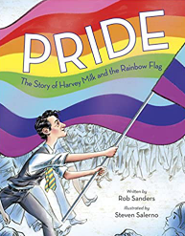  Guided Reading: DK Eyewitness Victorians  Class Reader: Tales from Beyond the Rainbow
Maths | 1- numbers to  1 000 000  2 Whole numbers – addition & subtraction | 3- Whole numbers multiplication & division  4 - word problems 5- graphs  6- fractions  7- decimals | 8- percentages  9- geometry  10- position and movement  11-measurements  12- area and perimeter  13- volume  14 roman numerals
Computing | Computer Science  Information Literacy  Online Safety | Media  Data Handling  Online Safety | Computer Science  Media  Online Safety
P.E | Netball  Gymnastics | Dance  OAA | Athletics  Rounders
Art | John Sargent  Georgia O’Keeffe  Watercolours  Oil pastels | Stephen Wiltshire  Landscape art  One point perspective  Cityscapes | L.S. Lowry  Charcoal  Sketchbook study  Figures
DT | Breads around the World | Frame structures  Bake a Victoria Sponge | Textiles – tie-dye pillow  Rock Cakes
History | The Maya Civilisation | The changing power of the monarchs | Victorians – Local Study
Geography | Mountains  - ‘Seven Summits’  - Features and formation  - UK mountains  - Himalayas | UK Geography  - Cities and counties  - geographical regions and their characteristics e.g. coastal regions  - how land use patterns have changed over time.  - Climate zones and vegetation belts (rethink food) | Human geography  - economic activity including trade links and the distribution of natural resources including energy, food, minerals and water  - Canals  - Land used for farming (our school was built on penneoaks farm)  - Economy today compared to what it was like in the past
Spanish | Talking about us/school subjects  Extended feelings, recap personal information, introduce a friend, subjects and opinions  Time in the city  Spanish city, buying a ticket, directions, descriptions, shopping, festive jumper | Healthy eating, going to market  Fruit and veg nouns, prices, market dialogue, recipe  Clothes  Clothes nouns, verb to wear, describe using adjectives, read descriptions | Out of this world Personal info conversations, names of planets, adjectives, prior learning recall  Going to the seaside  Items for the beach, persuasive sentences, visiting the seaside, read and understand facts about the beach
Music Tuition | Guitar  Singing | Guitar  Singing | Guitar  Singing
Experiences | Visit to the Cow and Calf  Hydroponic growing and harvesting – Mission to Mars | School Farm Visit  Rethink Food (Spring 2) Development Goals:  - Goal 3: Good Health and Wellbeing (PSHE)  - Goal 11: Sustainable Cities and Communities (Geography)  - Goal 15: Life on Land (English) | Bradford Industrial Museum  Look at heritage England maps of Victorian Bradford and compare with Bradford today
Opportunities for outdoor learning | Visit to the Cow and Calf
Opportunities for Aspirations | Helo planets talk with female scientist | Careers Week
Opportunities for Healthy Lifestyles | Visit to the Cow and Calf  Hydroponic growing and harvesting – Mission to Mars | Nutrition lead – Spanish healthy foods (fruits and vegetables) and recipes

