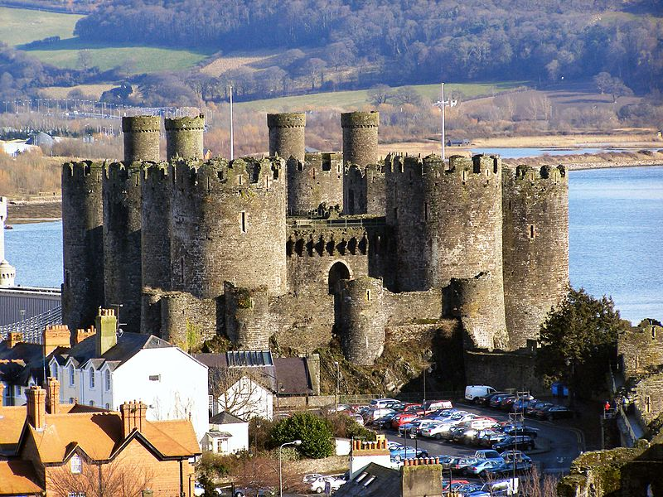

Maths

**Numbers to 10**

National Curriculum Objective:

Pupils should be taught identify one more and one less than a given number. The should identify and represent numbers using objects and pictorial representations including the number line, and use the language of: equal to, more than, less than (fewer), most, least. Pupils should read and write numbers from 1 to 20 in numerals and words.

**Addition and Subtraction**

National Curriculum Objective:

Pupils should read, write and interpret mathematical statements involving addition (+), subtraction (–) and equals (=) signs. They should represent and use number bonds and related subtraction facts within 20. Pupils will add and subtract one-digit and two-digit numbers to 20, including zero and solve one-step problems that involve addition and subtraction, using concrete objects and pictorial representations, and missing number problems such as 7 = – 9.

English

**Fiction- The Worst Princess**

**Non- Fiction: King Leonard’s Teddy**

Skills Covered:

Write a sequence of sentences to form short narratives, including personal experiences and those of others (real or fictional)

Use the joining word *and*

Use capital letters and full stops to demarcate some sentences accurately

Use capital letters for proper nouns

Use exclamation marks to demarcate some sentences

Use their Phase 2, Phase 3, Phase 4 and Phase 5 phonic knowledge to write words in ways which match their spoken sounds – many being spelt correctly and others being phonetically plausible

Spell most Year 1 common exception words taught

Form many lower case and capital letters accurately

Write with many letters accurate in shape and size, including capital letters and digits

Use spacing between words

Re-read writing to check that it makes sense

Read aloud their writing to each other and the teacher

**Castles**



History

**Queen VIcgtoria’s Reign**

National Curriculum Objective:

Pupils to look at the lives of significant individuals in the past who have contributed to national and international achievements. Children to look at significant historical events, people and places in their own locality.

**Skills covered:**

Sequence 3 or 4 artefacts from distinctly different periods of time

Match objects to people of different ages

They know and recount episodes from stories about the past

Use stories to encourage children to distinguish between fact and fiction.

Find answers to simple questions about the past from sources of information e.g. artefacts

Communicate their **knowledge** through:

Discussion….

Drawing pictures…

Drama/role play..

Making models…..

Writing..

Using ICT

Science

**Naming and Identifying Materials and Seasonal Changes**

National Curriculum Objective:

Pupils should be taught to distinguish between an object and the material from which it is made. They will identify and name a variety of everyday materials, including wood, plastic, glass, metal, water and rock.

Pupils should be taught to observe changes across the four seasons and describe weather associated with the seasons and how day length varies.

**Skills covered:**

Materials

Distinguish between an object and the material from which it is made

Identify and name a variety of everyday materials, including wood, plastic, glass, metal, water, and rock.

Seasonal Changes

Observe changes across the four seasons.

Observe and describe weather associated with the seasons



Art

**Sketching**

Children to use drawing to develop and share their ideas, experiences and imagination. They will develop a wide range of art and design techniques in using colour, pattern, texture, line, shape, form and space.

Skills covered:

Use a variety of tools, inc. pencils, rubbers, crayons, pastels, felt tips, charcoal, ballpoints, chalk and other dry media.

Begin to explore the use of line, shape and colour

Use a wide variety of media, inc. photocopied material, fabric, plastic, tissue, magazines, crepe paper, etc.

Work on their own, and collaboratively with others, on projects in 2 and 3 dimensions and on different scales.

Review what they and others have done and say what they think and feel about it. E.g. Annotate sketchbook

Make rubbings.

Build a repeating pattern and recognise pattern in the environment.

Use a sketchbook to gather and collect artwork.

PE

**Football and Gymnastics**

National Curriculum Objective:

Pupils should be able to engage in competitive (both against self and against others) and co-operative physical activities, in a range of increasingly challenging situations. Pupils should be taught to master basic movements including running, jumping, throwing and catching, as well as developing balance, agility and co-ordination, and begin to apply these in a range of activities They should participate in team games, developing simple tactics for attacking and defending. Pupils should perform dances using simple movement patterns

Skills Covered:

Games

Receives a ball with basic control

Beginning to develop hand-eye coordination

Participates in simple games

Understand the importance of rules in games.

Develop simple tactics and use them appropriately.

Beginning to develop an understanding of attacking/ defending.

Physical Active

Can comment on own and others performance

Can give comments on how to improve performance.

Use appropriate vocabulary when giving feedback.



DT

**Design and Create a Working Drawbridge**

Pupils to design purposeful, functional, appealing products for themselves and other users based on design criteria. Pupils will generate, develop, model and communicate their ideas through talking, drawing, templates, mock-ups and, where appropriate, information and communication technology.

Pupils to select from and use a range of tools and equipment to perform practical tasks [for example, cutting, shaping, joining and finishing]. They will select from and use a wide range of materials and components, including construction materials, textiles and ingredients, according to their characteristics.

Pupils will explore and evaluate a range of existing products. They will evaluate their ideas and products against design criteria

Skills covered:

Developing, planning and communicating ideas.

Draw on their own experience to help generate ideas

Suggest ideas and explain what they are going to do

Model their ideas in card and paper

Working with tools, equipment, materials and components to make quality products.

Make their design using appropriate techniques

With help measure, mark out, cut and shape a range of materials

Use tools eg scissors and a hole punch safely

Assemble, join and combine materials and components together using a variety of temporary methods e.g. glues or masking tape

Evaluate their product by discussing how well it works in relation to the purpose

Evaluate their products as they are developed, identifying strengths and possible changes they might make



PSHCE

H1. about what keeping healthy means; different ways to keep healthy

H2. about foods that support good health and the risks of eating too much sugar

H3. about how physical activity helps us to stay healthy; and ways to be physically active everyday

H5. simple hygiene routines that can stop germs from spreading

RE

I can say how it felt to make something.

I can remember the Christian Creation story and talk about it.

I can express an opinion about the Christian belief about creation.

ICT

To understand what algorithms are; how they are implemented as programs on digital devices; and that programs execute by following precise and unambiguous instructions. Create and debug simple programs. Use logical reasoning to predict the behaviour of simple programs. Recognise common uses of information technology beyond school.

Skills covered:

To Sequence a series of pre-written instructions to create an algorithm.

Break an activity down into simple steps

Independently list the steps in their own algorithms, test them and correct any mistakes

Combine more than one command into a device to make a simple program