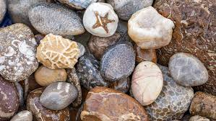

**Year 3 Autumn 2**

**The Stone Age**

**English**

**English Texts:**   
  
**Iqbal and his Ingenious Idea**,by Elizabeth Suneby

**A Christmas Carol**, by Kristina Stephenson

**Year 3 Writing Assessment Objectives:**

* write for both fictional and non-fictional purposes, drawing on their reading to inform the vocabulary and grammar of their writing
* use a range of co-ordinating and subordinating conjunctions
* use simple organisational devices (e.g. headings or subheadings) appropriately
* use present and past tense verb forms, mostly correctly and consistently
* begin to use paragraphs to structure writing
* describe settings and characters using expanded noun phrases
* use prepositions to express time and place
* spell most words correctly, adding prefixes and suffixes appropriately, spelling the correct form of homophones and spelling all common exception words correctly (KS1 and Y3)
* use the diagonal and horizontal strokes needed to join some letters make simple additions, revisions and proof- reading corrections to their own writing

**Maths**

**Chapter 8: Money**

* Counting Money
* Showing Amounts of Money
* Adding Money
* Subtracting Money
* Calculating Change
* Solving Word Problems

**Chapter 11: Time**

* Telling the Time

**Chapter 3:** Multiplication & Division

Multiplying by 3  
Multiplying by 4  
Multiplying by 4 and 8  
Multiplying by 8

**RE**

**Has Christmas lost its true meaning?**

* I can explain what Christmas means to me and talk about whether this involves giving and receiving presents
* I can start to explain the Christian belief that Jesus was God in human form and why God gave him to the world
* I can start to tell you what Christmas means to Christians and what it means to me

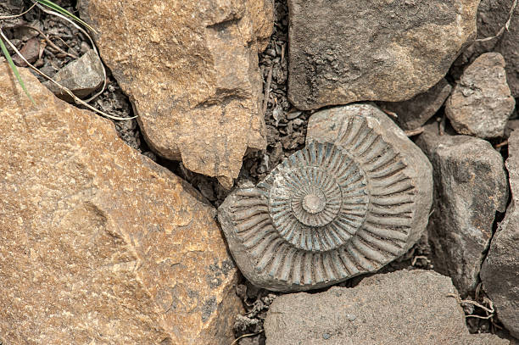

**Science**

**Rocks**

**National Curriculum:**

* Compare and group together different kinds of rocks on the basis of their appearance and simple physical properties
* Describe in simple terms how fossils are formed when things that have lived are trapped within rock  
  Recognise that soils are made from rocks and organic matter

**Progression in Skills:**

* Compare and group together different kinds of rocks on the basis of their appearance and simple physical properties
* Describe in simple terms how fossils are formed when things that have lived are trapped within rock
* Recognise that soils are made from rocks and organic matter

**PHSE – My Happy Mind**

**Ruby’s Worry** by Tom Percival

**Lesson Objectives:**

* How to focus their mind to help them train their brain.
* Learn about Team H-A- P and their roles in more detail.
* How our emotions impact Team H-A- P and how to support their brains to relax when feeling sad, stressed or worried.
* Why our Amygdala behaves the way it does and how evolution has shaped how it works.
* How we can use Happy Breathing during times of stress and how our Hippocampus stores the memory of this when we practice.
* About Neurons and Neural pathways and the role they play in learning.
* How to look after their brains to help them to be at their best

RSE:

* Know what risky means
* Be able to discuss risk and share their opinion on whether something is safe or not
* Know where to go for help if they need it

**Progression in Skills:**

* H15: that mental health, just like physical health, is part of daily life; the importance of taking care of mental health
* H16: about strategies and behaviours that support mental health - including how good quality sleep, physical exercise/time outdoors, being involved in community groups, doing things for others, clubs, and activities, hobbies and spending time with family and friends can support mental health and wellbeing
* H38: how to predict, assess and manage risk in different situations

**PHSE – The Story Project**

**Ruby’s Worry** by Tom Percival

**Lesson Objectives:**

* I can explain that everyone experiences ‘worries’, but I need to get help if these become overwhelming.
* I can explain where I can get help or advice.
* I can explain what to do if I can't ask my family and friends for help and what to do if it is someone in my family or one of my friends who is making me feel unsafe or unhappy.
* I can describe some physical signs of worry and I can explain what I should do if I am having lots of physical problems.
* I can describe some simple self-care techniques I can use when I am feeling worried.
* I can explain how children sometimes feel lonely and what children can do if they feel that way.

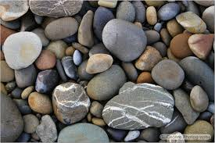

**Spanish**

**Numbers & Greetings**

**National Curriculum:**

* listen attentively to spoken language and show understanding by joining in and responding
* explore the patterns and sounds of language through songs and rhymes and link the spelling, sound and meaning of words
* engage in conversations; ask and answer questions; express opinions and respond to those of others; seek clarification and help
* speak in sentences, using familiar vocabulary, phrases and basic language structures
* develop accurate pronunciation and intonation so that others understand when they are reading aloud or using familiar words and phrases
* appreciate stories, songs, poems and rhymes in the language
* broaden their vocabulary and develop their ability to understand new words that are introduced into familiar written material, including through using a dictionary
* describe people, places, things and actions orally and in writing
* understand basic grammar appropriate to the language being studied, including (where relevant): feminine, masculine and neuter forms and the conjugation of high-frequency verbs; key features and patterns of the language; how to apply these, for instance, to build sentences; and how these differ from or are similar to English.

**Progression in Skills:**

* Can say a greeting
* Can respond to a question about feelings and name
* Can attempt a question about name and feelings
* Can remember and say most numbers from 1 to 10
* Can say at least four colours

**DT**

**National Curriculum:**

* Generate, develop, model and communicate their ideas through discussion, annotated sketches, cross-sectional and exploded diagrams, prototypes, pattern pieces and computer-aided design
* Select from and use a wider range of tools and equipment to perform practical tasks [for example, cutting, shaping, joining and finishing], accurately
* Evaluate their ideas and products against their own design criteria and consider the views of others to improve their work
* To test, evaluate and refine their ideas and products against a specification, taking into account the views of intended users and other interested groups
* To understand and apply the principles of a healthy and varied diet
* To prepare and cook a variety of predominantly savoury dishes using a range of cooking techniques
* To understand seasonality, and know where and how a variety of ingredients are grown, reared, caught and processed

**Progression in Skills:**

* Explore, develop and communicate design proposals by modelling ideas
* Select tools and techniques for making their product
* Think about their ideas as they make progress and be willing change things if this helps them improve their work
* Evaluate their product against original design criteria e.g. how well it meets its intended purpose
* Demonstrate hygienic food preparation and storage

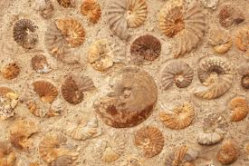

**Geography**

**Effects of human activities on the UKs landscape**

**National Curriculum:**

* Name and locate counties and cities of the United Kingdom, geographical regions and their identifying human and physical characteristics, key topographical features (including hills, mountains, coasts and rivers), and land-use patterns; and understand how some of these aspects have changed over time.
* Human geography, including: types of settlement and land use, economic activity including trade links, and the distribution of natural resources including energy, food, minerals and water
* Use the eight points of a compass, four and six-figure grid references, symbols and key (including the use of Ordnance Survey maps) to build their knowledge of the United Kingdom and the wider world

**Progression in Skills:**

* Begin to ask/initiate geographical questions.
* Analyse evidence and begin to draw conclusions e.g. make comparisons between two locations using photos/ pictures, temperatures in different locations.
* Use letter/no. co-ordinates to locate features on a map.
* Know why a key is needed.
* Begin to identify points on maps A,B and C
* Begin to draw a sketch map from a high view point.
* Try to make a map of a short route experienced, with features in correct order.
* Try to make simple scale drawing.

**Computing**

**Information Literacy**

**National Curriculum:**

* Use search technologies effectively, appreciate how results are selected and ranked.
* Use technology safely, respectfully and responsibly; recognise acceptable/unacceptable behaviour;
* identify a range of ways to report concerns about content and contact.

**Progression in Skills:**

* Follow a process
* Explain what makes a secure password
* Recognise similarities between using digital devices and using non-digital tools
* Suggest differences between using digital devices and using non-digital tools
* Explain how messages are passed through multiple connections
* Recognise that a computer network is made up of a number of devices
* Demonstrate how information can be passed between devices
* Explain the role of a switch, server, and wireless access point in a network
* Identify how devices in a network are connected together

**Computing**

**Computer Science**

**National Curriculum:**

* Write and debug programs that accomplish specific goals, including controlling or simulating physical systems; solve problems by decomposing them into smaller parts.
* Use logical reasoning to explain how some simple algorithms work and to detect and correct errors in algorithms and programs.

**Progression in Skills:**

* Create a simple program using one input
* Create a program using input and output devices

**Computing**

**Computer Science**

**National Curriculum:**

* Write and debug programs that accomplish specific goals, including controlling or simulating physical systems; solve problems by decomposing them into smaller parts.
* Use logical reasoning to explain how some simple algorithms work and to detect and correct errors in algorithms and programs.

**Progression in Skills:**

* Create a simple program using one input
* Create a program using input and output devices



**Oracy**

**National Curriculum:**

* Listen and respond appropriately to adults and their peers
* Ask relevant questions to extend their understanding and knowledge
* Use relevant strategies to build their vocabulary
* Articulate and justify answers, arguments and opinions

**Progression in Skills:**

* Be able to listen to complex information and work out most of the key information (some support may be required to help them to work out the next steps) e.g. ‘Tell your partner three facts about ... using the right words if you can and then write them down.’
* Recognise the cause and effect element of spoken instructions, that there may be consequences if certain instructions are not followed e.g. ‘Everyone needs to stop talking and listen now, otherwise we will be late for break.’
* Ask a range of different types of questions to find out specific information including ‘how’ and ‘why’ e.g. ‘How do we know this was from Ancient Roman times?’
* Be aware of when they haven’t understood something because of the vocabulary used and ask a general clarification question e.g. ‘What does that long word mean?’
* Experiment with new vocabulary in different contexts to test out understanding and to learn from mistakes e.g. ‘The land around the arctic has no trees and is called the tundrum.’ (Meaning ‘tundra’)
* Give reasons and explanations for choices and viewpoints in class discussions e.g. ‘I think the ending of the book is better than the ending in the film because sometimes things don’t work out well for people in real life.’

**P.E**

**Gymnastics**

**National Curriculum:**

* Pupils should continue to apply and develop a broader range of skills, learning how to use them in different ways and to link them to make actions and sequences of movement. They should enjoy communicating, collaborating and competing with each other. They should develop an understanding of how to improve in different physical activities and sports and learn how to evaluate and recognise their own success.
* Develop flexibility, strength, technique, control and balance [for example, through athletics and gymnastics].
* Compare their performances with previous ones and demonstrate improvement to achieve their personal best.

**Progression in Skills:**

* Modify actions independently using different pathways, directions and shapes
* Identify similarities and differences in sequences
* Perform sequences with contrasting actions
* Perform in unison with a partner
* Remember and repeat sequences
* Adapt basic sequences to include some apparatus
* Show body control in individual movements and sequences
* Work as a group to create a basic sequence