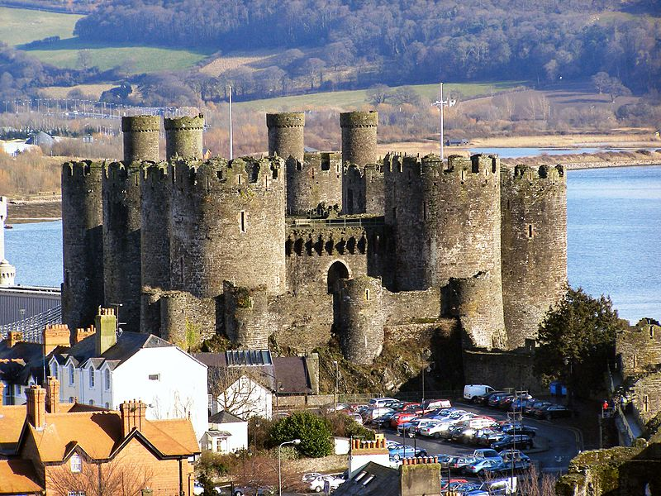

English

**Fiction- The King who Banned the Dark**

**Non- Fiction: In the Castle**

Skills Covered:

Write a sequence of sentences to form short narratives, including personal experiences and those of others (real or fictional)

Use the joining word and

Use simple past and present verbs mostly accurately

Use capital letters and full stops to demarcate some sentences accurately

Use capital letters for proper nouns use question marks to demarcate some sentences

Use exclamation marks to demarcate some sentences

Use their Phase 2, Phase 3, Phase 4 and Phase 5 phonic knowledge to write words in ways which match their spoken sounds – many being spelt correctly and others being phonetically plausible

Add the suffixes –ing, -ed

Spell most Year 1 common exception words taught

Form many lower case and capital letters accurately

Write with many letters accurate in shape and size, including capital letters and digits use spacing between words

Re-read writing to check that it makes sense

Read aloud their writing to each other and the teacher

Maths

**Position**

National Curriculum Objective:

Ppuils to sequence events in chronological order using language [for example, before and after, next, first, today, yesterday, tomorrow, morning, afternoon and evening].

**Numbers to 20**

National Curriculum Objective:

Pupils should be taught identify one more and one less than a given number. The should identify and represent numbers using objects and pictorial representations including the number line, and use the language of: equal to, more than, less than (fewer), most, least. Pupils should read and write numbers from 1 to 20 in numerals and words.

**Addition and Subtraction to 20**

National Curriculum Objective:

Pupils should read, write and interpret mathematical statements involving addition (+), subtraction (–) and equals (=) signs. They should represent and use number bonds and related subtraction facts within 20. Pupils will add and subtract one-digit and two-digit numbers to 20, including zero and solve one-step problems that involve addition and subtraction, using concrete objects and pictorial representations, and missing number problems such as 7 = – 9.

**Castles**



Science

**Materials and Seasonal Changes**

National Curriculum Objective:

Pupils should be taught to distinguish between an object and the material from which it is made. They will identify and name a variety of everyday materials, including wood, plastic, glass, metal, water and rock. They will describe the simple physical properties of a variety of everyday materials and compare and group together a variety of everyday materials on the basis of their simple physical properties.

Pupils should be taught to observe changes across the four seasons and describe weather associated with the seasons and how day length varies.

**Skills covered:**

Working Scientifically

To ask simple questions and recognise that they can be answered in different ways.

To use simple equipment to observe closely.

To Identify and classify

To use his/her observations and ideas to suggest answers to questions

Materials

To distinguish between an object and the material from which it is made

To identify and name a variety of everyday materials, including wood, plastic, glass, metal, water, and rock.

To describe the simple physical properties of a variety of everyday materials.

Seasonal Changes

To observe changes across the four seasons.

To observe and describe weather associated with the seasons and how day length varies.

Geography

**The United Kingdom**

National Curriculum Objective:

Location Knowledge- Pupils to name, locate and identify characteristics of the four countries and capital cities of the United Kingdom and its surrounding seas.

Human and Physical Geography- Puils to use basic geographical vocabulary to refer to: key physical features.

Geographical Skills and Fieldwork- use world maps, atlases and globes to identify the United Kingdom and its countries, as well as the countries, continents and oceans studied at this key stage.

Skills covered:

Teacher led enquiries, to ask and respond to simple closed questions.

Use information books/pictures as sources of information.

Investigate their surroundings

Make observations about where things are e.g. within school or local area.

Using Maps

Recognise that it is about a place.

Use relative vocabulary (e.g. bigger/smaller, like/dislike)

Learn names of some places within/around the UK. E.g. Home town, cities, countries e.g. Wales, France.  

Picture maps and globes

Find land/sea on globe.

Follow directions (Up, down, left/right, forwards/backwards)

Draw picture maps of imaginary places and from stories.

Representation

Use own symbol on imaginary map.

Perspective

Draw around objects to make a plan.

Using Maps

Use simple picture map to move around the school.



Art

**Portraits and Self- Portraits**

Pupils to use drawing, painting and sculpture to develop and share their ideas, experiences and imagination. Pupils to learn about the work of a range of artists, craft makers and designers, describing the differences and similarities between different practices and disciplines, and making links to their own work.

Mix and match colours to artefacts and objects.

Use a wide variety of media, inc. photocopied material, fabric, plastic, tissue, magazines, crepe paper, etc.

Work on their own, and collaboratively with others, on projects in 2 and 3 dimensions and on different scales.

Review what they and others have done and say what they think and feel about it. E.g. Annotate sketchbook

Mix secondary colours and shades

Using different types of paint.

Create different textures e.g. use of sawdust.

Make marks in print with a variety of objects, including natural and made objects.

Carry out different printing techniques e.g. monoprint, block, relief and resist printing.

Make rubbings.

Build a repeating pattern and recognise pattern in the environment.

Use a sketchbook to gather and collect artwork.

PE

**Gymnastics**

National Curriculum Objective:

Pupils should develop fundamental movement skills, become increasingly competent and confident and access a broad range of opportunities to extend their agility, balance and coordination, individually and with others. They should be able to engage in competitive (both against self and against others) and co-operative physical activities, in a range of increasingly challenging situations.

Skills Covered:

Gymnastics

Copies and explores basic movements with some control and coordination.

Can perform different body shapes.

Performs at different levels.

Can perform a 2 footed jump.

Can use equipment safely.

Balances with some control.

Can link 2-3 simple movements.

Physical Active

Can comment on own and others performance

Can give comments on how to improve performance.

Use appropriate vocabulary when giving feedback.



ICT

Use technology safely and respectfully, keeping personal information private; identify where to go for help and support when they have concerns about content or contact on the internet or other online technologies.

Recognise common uses of information technology beyond school.

Skills covered:

Use a mouse/touchscreen/tablet to follow the appropriate buttons to navigate to websites

Understand the internet is fun but just like there are rules in the real world to keep you safe there are rules for keeping them safe in the online world.

DT

**Cooking and Nutrition- Royal Feast**

Pupils to design purposeful, functional, appealing products for themselves and other users based on design criteria. Pupils will generate, develop, model and communicate their ideas through talking, drawing, templates, mock-ups and, where appropriate, information and communication technology.

Cooking and nutrition Pupils to use the basic principles of a healthy and varied diet to prepare dishes and understand where food comes from

They will select from and use a wide range of materials and components, including construction materials, textiles and ingredients, according to their characteristics.

Pupils will explore and evaluate a range of existing products. They will evaluate their ideas and products against design criteria

Skills covered:

Developing, planning and communicating ideas.

Suggest ideas and explain what they are going to do

Develop their design ideas applying findings from their earlier research

Working with tools, equipment, materials and components to make quality products (inc-food)

Make their design using appropriate techniques

Select and use appropriate fruit and vegetables, processes and tools

Use basic food handling, hygienic practices and personal hygiene

Use simple finishing techniques to improve the appearance of their product.

Evaluating processes and products

Evaluate their product by discussing how well it works in relation to the purpose

Evaluate their products as they are developed, identifying strengths and possible changes they might make

Evaluate their product by asking questions about what they have made and how they have gone about it.



PSHCE

**Keeping safe around household products;**

**How to ask for help if worried.**

H11. about different feelings that humans can experience

H12. how to recognise and name different feelings

H13. how feelings can affect people’s bodies and how they behave H14. how to recognise what others might be feeling.

H16. about ways of sharing feelings; a range of words to describe feelings

H30. about how to keep safe at home (including around electrical appliances) and fire safety (e.g. not playing with matches and lighters)

H31. that household products (including medicines) can be harmful if not used correctly

H32. ways to keep safe in familiar and unfamiliar environments (e.g. beach, shopping centre, park, swimming pool, on the street) and how to cross the road safely

RE

I can talk about a gift that is special to me

I can remember some of the Christmas story.

I can suggest a gift I would give to Jesus.

Music

**Rhythm in the way we walk and Banan Rap**

Pupils should be taught to use their voices expressively and creatively by singing songs and speaking chants and rhymes.

**Voice expressively.**

To find their singing voice and use their voices confidently.

Sing a melody accurately at their own pitch.

Sing with a sense of awareness of pulse and control of rhythm.

Recognise phrase lengths and know when to breathe.

Sing songs expressively.

Begin to sing with control of pitch (e.g. following the shape of the melody).

Follow pitch movements with their hands and use high, low and middle voices.

Sing with an awareness of other performers.

**Controlling pulse and rhythm**

Identify the pulse in different pieces of music.

• Identify the pulse and join in getting faster and slower together.

• Identify long and short sounds in music.

Perform a rhythm to a given pulse.

Begin to internalise and create rhythmic patterns.

Accompany a chant or song by clapping or playing the pulse or rhythm.

**Listening, Memory and Movement**

Recall and remember short songs and sequences and patterns of sounds.

Respond physically when performing, composing and appraising music.

Identify different sound sources.

**Performance skills**

Perform together and follow instructions that combine the musical elements.