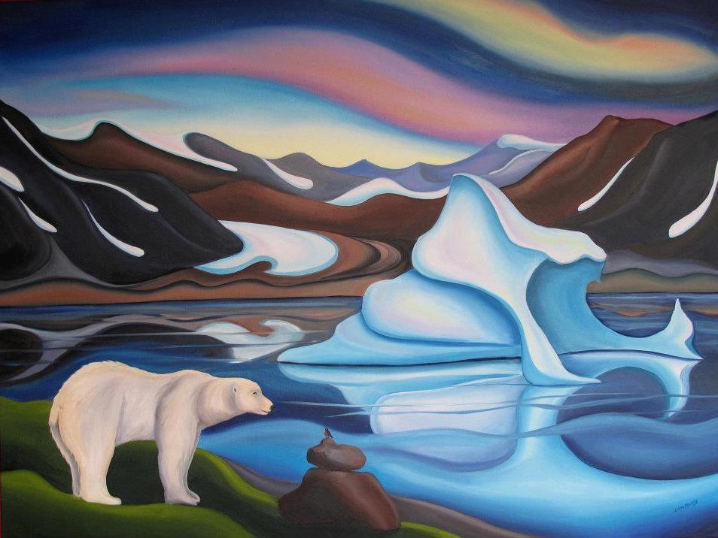

**Year 3 Spring 1**

**Here, There & Everywhere**

**Maths**

**Chapter 3:** Multiplication & Division

* Multiplying by 3
* Multiplying by 4
* Multiplying by 4 and 8
* Multiplying by 8

**Chapter 9: Time**

* Measuring time in seconds
* Measuring and comparing time in seconds
* Finding duration in minutes
* Finding start times and end times
* Finding duration in hours

**Chapter 12: Angles**

* Making Angles
* Finding Right Angles
* Finding Different Angles
* Finding Angles in Shapes
* Comparing Angles
* Making Turns

**RE**

**Could Jesus Help People?**

* I can talk about some of the things in the world that people think of as miracles and begin to tell you about a miracle I would like to see happen today.
* I can explain one Christian viewpoint about one of Jesus’ healing miracles.
* I can start to say whether I believe Jesus actually healed people or not.

**English**

**English Texts:**   
  
**Once Upon a Snowstorm**,by Richard Johnson

**Emmanuel's Dream: The True Story of Emmanuel Ofosu Yeboah:**, by Laurie Ann Thompson   
  
**Year 3 Writing Assessment Objectives:**

* write for both fictional and non-fictional purposes, drawing on their reading to inform the vocabulary and grammar of their writing
* use correct tense consistently, including the present perfect tense
* maintain Standard English forms, e.g. using a/an correctly
* begin to use paragraphs to structure writing
* use simple organisational devices (e.g. headings or sub-headings) appropriately
* describe settings and characters using expanded noun phrases
* use prepositions to express place and time
* begin to use inverted commas to punctuate speech
* spell most words correctly, adding prefixes and suffixes appropriately, spelling the correct form of homophones and spelling all common exception words correctly (KS1 and Y3)
* use the diagonal and horizontal strokes needed to join some letters
* make simple additions, revisions and proof-reading corrections to their own writing



**Spanish**

**Animals**

**National Curriculum:**

* listen attentively to spoken language and show understanding by joining in and responding
* explore the patterns and sounds of language through songs and rhymes and link the spelling, sound and meaning of words
* engage in conversations; ask and answer questions; express opinions and respond to those of others; seek clarification and help
* speak in sentences, using familiar vocabulary, phrases and basic language structures
* develop accurate pronunciation and intonation so that others understand when they are reading aloud or using familiar words and phrases
* present ideas and information orally to a range of audiences
* read carefully and show understanding of words, phrases and simple writing
* appreciate stories, songs, poems and rhymes in the language
* broaden their vocabulary and develop their ability to understand new words that are introduced into familiar written material, including through using a dictionary
* write phrases from memory, and adapt these to create new sentences, to express ideas clearly
* describe people, places, things and actions orally and in writing
* understand basic grammar appropriate to the language being studied, including (where relevant): feminine, masculine and neuter forms and the conjugation of high-frequency verbs; key features and patterns of the language; how to apply these, for instance, to build sentences; and how these differ from or are similar to English.

**Progression in Skills:**

* Can remember and say animal nouns
* Can attempt to write accurately a number and an animal in the plural
* Can say a simple sentence to say which animal they have
* Can say a simple sentence to say their favourite animal

**Science**

**Animals Including Humans**

**National Curriculum:**

* identify that animals, including humans, need the right types and amount of nutrition, and that they cannot make their own food; they get nutrition from what they eat
* identify that humans and some other animals have skeletons and muscles for support, protection and movement

**Progression in Skills:**

* identify that animals, including humans, need the right types of nutrition, and that they cannot make their own food; they get nutrition from what they eat
* identify that humans and some other animals have skeletons and muscles for support, protection and movement

**Geography**

**National Curriculum:**

* Identify the position and significance of latitude, longitude, equator, Northern Hemisphere, Southern Hemisphere, the Tropics of Cancer and Capricorn, Arctic and Antarctic Circle and time zones.

**Progression in Skills:**

* Use NF books, stories, atlases, pictures/photos and internet as sources of information.
* Begin to collect and record evidence
* Analyse evidence and begin to draw conclusions e.g. make comparisons between two locations using photos/ pictures, temperatures in different locations.
* Locate places on larger scale maps e.g. map of Europe. Follow a route on a map with some accuracy. (e.g. whilst orienteering)
* Use letter/no. co-ordinates to locate features on a map

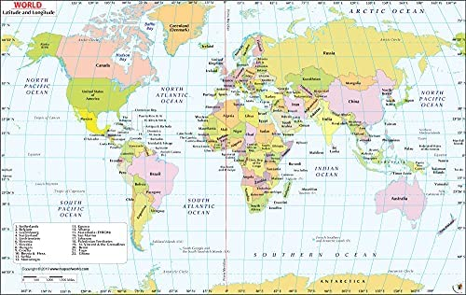

**PHSE – My Happy Mind**

**Celebrate**

**Lesson Objectives:**

* That scientists discovered that we all have 24 character strengths but in different amounts.
* We all have 24 strengths but focus on the 5 main categories of character strengths and think about them like a pick and mix bag of sweets.
* That half of our character is set by genetics and the other half from our experiences.
* That our character can grow based on our experiences, just like their brains do with Neuroplasticity.
* Why it is important to spot strengths in others and how they can be used.
* That strengths can help them to approach difficult situations.
* When they use their character strengths, they can be their best selves because they are feeling happy, safe, and calm, and this makes Team H-A- P happy.

**Progression in Skills:**

* H27: to recognise their individuality and personal qualities

**Art**

**National Curriculum:**

* Pupils should be taught to develop their techniques, including their control and their use of materials, with creativity, experimentation and an increasing awareness of different kinds of art, craft and design.
* Pupils should be taught to create sketch books to record their observations and use them to review and revisit ideas
* to improve their mastery of art and design techniques, including drawing, painting and sculpture with a range of materials [for example, pencil, charcoal, paint, clay]

**Progression in Skills:**

* Question and make thoughtful observations about starting points and select ideas to use in their work.
* Adapt their work according to their views and describe how they might develop it further.
* Experiment with different grades of pencil and other implements.
* Draw for a sustained period of time at their own level.
* Plan, refine and alter their drawings as necessary.
* Experiment with different effects and textures inc. washes
* Experiment with a range of media e.g. overlapping, layering etc

**Computing**

**Media**

**National Curriculum:**

Select, use and combine a variety of software (including internet services) on a range of digital devices to design and create a range of programs, systems and content that accomplish given goals, including collecting, analysing, evaluating and presenting data and information

**Progression in Skills:**

* Create and amend a range of texts for a specific purpose.
* Create and combine visual media to meet a specific need.

**PHSE – The Story Project**

**No Money Day** by Kate Miller

**Lesson Objectives:**

* I can tell you some of the ways people pay for things and some of the decisions people make about spending money.
* I can tell you how money can affect people’s emotions.
* I can tell you some of the reasons people spend or save money.
* I can tell you what ‘borrowed’ means and why people might borrow money.
* I can tell you how to keep money and possessions safe.



**Music**

**Singing**

**National Curriculum:**

* improvise and compose music for a range of purposes using the inter-related dimensions of music
* listen with attention to detail and recall sounds with increasing aural memory

**Progression in Skills:**

* Recognise rhythmic patterns.
* Perform a repeated pattern to a steady pulse.
* Identify and recall rhythmic and melodic patterns.
* Identify repeated patterns used in a variety of music. (Ostinato).
* Sing with confidence using a wider vocal range.
* Sing in tune.
* Sing with awareness of pulse and control of rhythm.
* Recognise simple structures. (Phrases).
* Sing expressively with awareness and control at the expressive elements. E.g. timbre, tempo, dynamics.
* Sing songs and create different vocal effects.
* Understand how mouth shapes can affect voice sounds.
* Internalise sounds by singing parts of a song ‘in their heads.’

**Music**

**Ukulele**

**National Curriculum:**

* play and perform in solo and ensemble contexts, using their voices and playing musical instruments with increasing accuracy, fluency, control and expression
* use and understand staff and other musical notations

**Progression in Skills:**

* Identify melodic phrases and play them by ear.
* Select instruments to describe visual images.
* Choose instruments on the basis of internalised sounds.
* Identify ways sounds are used to accompany a song.
* Analyse and comment on how sounds are used to create different moods.
* Explore and perform different types of accompaniment.
* Explore and select different melodic patterns.
* Recognise and explore different combinations of pitch sounds
* Create textures by combining sounds in different ways.
* Create music that describes contrasting moods/emotions.
* Improvise simple tunes based on the pentatonic scale.
* Compose music in pairs and make improvements to their own work.
* Create an accompaniment to a known song.
* Create descriptive music in pairs or small groups.
* Perform long and short sounds in response to symbols.
* Create long and short sounds on instruments.
* Play and sing phrase from dot notation.
* Record their own ideas.
* Make their own symbols as part of a class score.

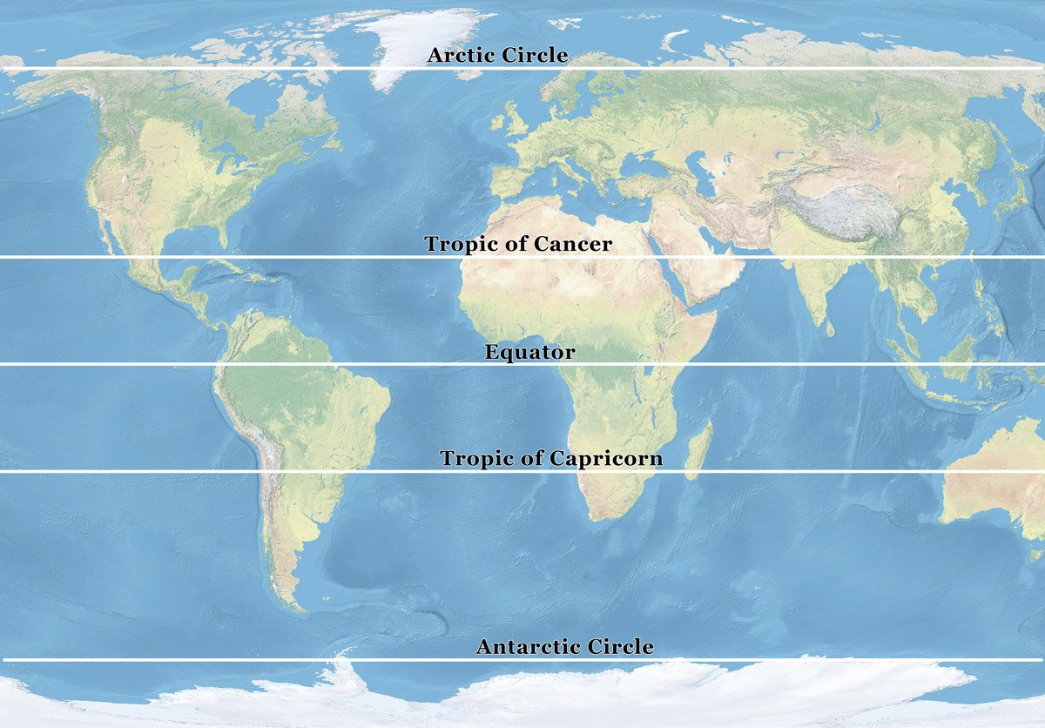

**Oracy**

**National Curriculum:**

* Give well-structured descriptions, explanations and narratives for different purposes, including for expressing feelings
* Maintain attention and participate actively in collaborative conversations, staying on topic and initiating and responding to comments
* Use spoken language to develop understanding through speculating, hypothesising, imagining and exploring ideas
* Speak audibly and fluently with an increasing command of standard English

**Progression in Skills:**

* Tell a story with a clear structure including the setting and ideas linked in different ways e.g. ‘On holiday me and Dad went to the seaside. It was great because Dad helped me build a massive sandcastle which I decorated with shells and seaweed. I took a photo of it because after a while the waves started washing it away.’
* Discuss how a character may be feeling and why e.g. ‘I think he might be feeling confused because he doesn’t understand why his cat has died.’
* Able to use conjunctions to increase the length and grammatical complexity of sentences e.g. ‘before, after, while, so’
* Able to initiate conversations with unfamiliar adults (in school or in a safe environment) and pupils
* Understand how language is used to investigate and reflect on feelings e.g. ‘I feel sad because Jane is leaving. How do you feel?’
* Produce speech that is consistently clear and easy to understand
* Able to say words of any length with accuracy
* Use phonological awareness skills when spelling, although some mistakes may still be made
* Able to signal punctuation and emphasise meaning through the use of intonation e.g. pausing to divide speech into intelligible ‘chunks’ of meaning.

**P.E**

**Dance**

**National Curriculum:**

* Pupils should continue to apply and develop a broader range of skills, learning how to use them in different ways and to link them to make actions and sequences of movement. They should enjoy communicating, collaborating and competing with each other. They should develop an understanding of how to improve in different physical activities and sports and learn how to evaluate and recognise their own success.
* Develop flexibility, strength, technique, control and balance [for example, through athletics and gymnastics].
* Perform dances using a range of movement patterns.
* Compare their performances with previous ones and demonstrate improvement to achieve their personal best.

**Progression in Skills:**

* Discuss own and others’ work with some awareness of choreography
* Describe using appropriate language the features of dances performed by others
* Competently include props in their routines
* Perform movements to an audience
* Express moods and feeling of character through the dance piece
* Attempt short pieces of improvised dance responding to the structure/theme of the dance
* Dance using different levels and direction
* Share and create short dance phrases with a partner and in small groups
* Work to develop to take part in group and whole class dance