

**Year 3 Spring 2**

**Here, There & Everywhere**

**RE**

**Easter**

* I can suggest how a person may rescue/help others who are in difficult situations
* I can start to tell you why Christians believe Jesus’ death is important
* I can start to reflect on whether I agree with Christian beliefs about Jesus’ death

**English**

**English Texts:**   
  
**There’s a Ran-Tang in my bedroom**,by James Sellick  
  
**Year 3 Writing Assessment Objectives:**

* write for both fictional and non-fictional purposes, drawing on their reading to inform the vocabulary and grammar of their writing
* use a range of co-ordinating and subordinating conjunctions
* use adverbs to express time
* use correct tense consistently, including the present perfect tense
* begin to use paragraphs to structure writing
* spell most words correctly, adding prefixes and suffixes appropriately, spelling the correct form of homophones and spelling all common exception words correctly (KS1 and Y3)
* use the diagonal and horizontal strokes needed to join some letters
* make simple additions, revisions and proof-reading corrections to their own writing

**Maths**

**Chapter 4: Further Multiplication & Division**

* Multiplying 2-Digit Numbers
* Multiplying with Renaming
* Dividing 2-Digit Numbers
* Dividing with Renaming
* Solving Word Problems

**Chapter 5: Length**

* Writing Length in Metres and Centimetres
* Writing Length in Centimetres
* Writing Length in Centimetres and Millimetres
* Comparing Lengths
* Solving Word Problems

**Chapter 14: Perimeter of Figures**

* Measuring Total Length Around a Shape
* Measuring Perimeter
* Calculating Perimeter



**Spanish**

**Carnival & Numbers**

**National Curriculum:**

* listen attentively to spoken language and show understanding by joining in and responding
* explore the patterns and sounds of language through songs and rhymes and link the spelling, sound and meaning of words
* engage in conversations; ask and answer questions; express opinions and respond to those of others; seek clarification and help
* speak in sentences, using familiar vocabulary, phrases and basic language structures
* develop accurate pronunciation and intonation so that others understand when they are reading aloud or using familiar words and phrases
* present ideas and information orally to a range of audiences
* read carefully and show understanding of words, phrases and simple writing
* appreciate stories, songs, poems and rhymes in the language
* broaden their vocabulary and develop their ability to understand new words that are introduced into familiar written material, including through using a dictionary
* write phrases from memory, and adapt these to create new sentences, to express ideas clearly
* describe people, places, things and actions orally and in writing
* understand basic grammar appropriate to the language being studied, including (where relevant): feminine, masculine and neuter forms and the conjugation of high-frequency verbs; key features and patterns of the language; how to apply these, for instance, to build sentences; and how these differ from or are similar to English.

**Progression in Skills:**

* Can remember and use core language from Autumn Term
* Can recall numbers to 10
* Can remember some numbers between 10 and 20
* Can express their age

**Science**

**Plants**

**National Curriculum:**

* explore the requirements of plants for life and growth (air, light, water, nutrients from soil, and room to grow) and how they vary from plant to plant
* investigate the way in which water is transported within plants
* explore the part that flowers play in the life cycle of flowering plants, including pollination, seed formation and seed dispersal

**Progression in Skills:**

* Identify and describe the functions of different parts of flowering plants: roots, stem/trunk, leaves and flowers
* • Explore the requirements of plants for life and growth (air, light, water, nutrients from soil, and room to grow) and how they vary from plant to plant
* • Investigate the way in which water is transported within plants
* • Explore the part that flowers play in the life cycle of flowering plants, including pollination, seed formation and seed dispersal

**Geography**

**National Curriculum:**

* Describe and understand key aspects of physical geography including climate zones and biomes.

**Progression in Skills:**

* Begin to collect and record evidence
* Begin to ask/initiate geographical questions
* Analyse evidence and begin to draw conclusions e.g. make comparisons between two locations using photos/ pictures, temperatures in different locations.
* Begin to identify points on maps A,B and C
* Begin to use junior atlases.



**Music**

**National Curriculum:**

* Play and perform in solo and ensemble contexts, using their voices and playing musical instruments with increasing accuracy, fluency, control and expression.
* Improvise and compose music for a range of purposes using the inter-related dimensions of music.
* Listen with attention to detail and recall sounds with increasing aural memory.
* Use and understand staff and other musical notations.
* Appreciate and understand a wide range of high-quality live and recorded music drawn from different traditions and from great composers and musicians.
* Develop an understanding of the history of music.

**Progression in Skills:**

* Pupils will explore how music has developed through different periods, styles and cultures in regards to –

- Pulse  
- Tempo  
- Rhythm  
- Dynamics  
- Pitch  
- Texture

* Pupils will be able to constructively express their thoughts on performances including peer feedback developing listening skills and musical vocabulary.

**DT**

**National Curriculum:**

* Use research and develop design criteria to inform the design of innovative, functional, appealing products that are fit for purpose, aimed at particular individuals or groups
* Generate, develop, model and communicate their ideas through discussion, annotated sketches, cross-sectional and exploded diagrams, prototypes, pattern pieces and computer-aided design
* Select from and use a wider range of tools and equipment to perform practical tasks [for example, cutting, shaping, joining and finishing], accurately
* Select from and use a wider range of materials and components, including construction materials, textiles and ingredients, according to their functional properties and aesthetic qualities
* Investigate and analyse a range of existing products
* Evaluate their ideas and products against their own design criteria and consider the views of others to improve their work

**Progression in Skills:**

* Identify a purpose and establish criteria for a successful product.
* Make drawings with labels when designing
* Select tools and techniques for making their product
* Measure, mark out, cut, score and assemble components with more accuracy
* Work safely and accurately with a range of simple tools
* Measure, tape or pin, cut and join fabric with some accuracy
* Evaluate their product against original design criteria e.g. how well it meets its intended purpose

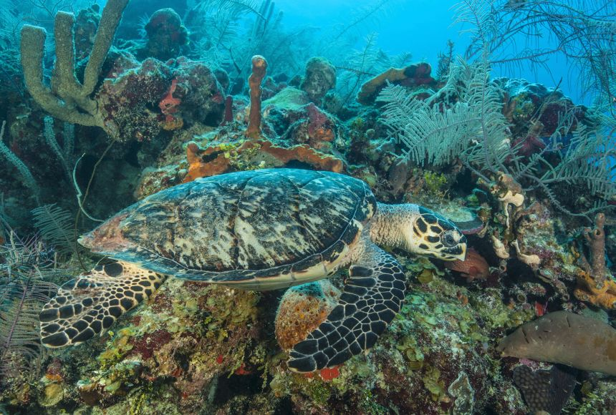

**PHSE – The Story Project**

**Faruq and the Wiri Wiri** by Sophia Payne

**Lesson Objectives:**

* I can explain how food contributes to a balanced lifestyle
* I can tell you some principles of planning and preparing a range of healthy meals
* I can make choices about the food I eat and I can tell you what affects the choices I make
* I can tell you how drinks contribute to a healthy lifestyle
* I can tell you what influences my goals and dreams for the future

**PHSE – My Happy Mind**

**Appreciate**

**Health & Wellbeing – keeping healthy**

**Lesson Objectives:**

* That we can forget to appreciate what is around us and that Happy Breathing can help us appreciate the little things we may forget.
* That the more they show gratitude, the easier it is - like Neuroplasticity.
* How to develop an Attitude of Gratitude, what happens when we give gratitude and how the giver and receiver feel.
* That Dopamine gets released in their brain when they give gratitude and that this helps Team H-A- P work together.
* How Dopamine can especially help the Amygdala stay calm and that even the thought of gratitude can release Dopamine.
* How when they appreciate themselves and feel good about their strengths, they will use them even more. They can use characters' strengths as a way to appreciate others too.

**Progression in Skills:**

* H5: about what good physical health means; how to recognise early signs of physical illness
* H6: about what constitutes a healthy diet; how to plan healthy meals; benefits to health and wellbeing of eating nutritionally rich foods; risks associated with not eating a healthy diet including obesity and tooth decay
* H9: that bacteria and viruses can affect health; how everyday hygiene routines can  limit the spread of infection; the wider importance of personal hygiene and how to maintain it
* H10: how medicines, when used responsibly, contribute to health; that some diseases can be prevented by vaccinations and immunisations; how allergies can be managed
* H11: how to maintain good oral hygiene (including correct brushing and flossing); why regular visits to the dentist are essential; the impact of lifestyle choices on dental care (e.g sugar consumption/acidic drinks such as fruit juices, smoothies and fruit teas; the effects of smoking)
* H12: about the benefits of sun exposure and risks of overexposure; how to keep safe from sun damage and sun/heat stroke and reduce the risk of skin cancer
* H14: how and when to seek support, including which adults to speak to in and outside school, if they are worried about their health

**Computing**

**Data Handling**

**National Curriculum:**

* Use technology safely, respectfully and responsibly;
* Recognise acceptable/unacceptable behaviour;
* Identify a range of ways to report concerns about content and contact.

**Progression in Skills:**

* Create simple graphs using ICT to organise, present and understand data.
* Answer questions in an existing database
* Be able to search a database using more than one search term.



**Oracy**

**National Curriculum:**

* Give well-structured descriptions, explanations and narratives for different purposes, including for expressing feelings
* Maintain attention and participate actively in collaborative conversations, staying on topic and initiating and responding to comments
* Use spoken language to develop understanding through speculating, hypothesising, imagining and exploring ideas
* Speak audibly and fluently with an increasing command of standard English

**Progression in Skills:**

* Tell a story with a clear structure including the setting and ideas linked in different ways e.g. ‘On holiday me and Dad went to the seaside. It was great because Dad helped me build a massive sandcastle which I decorated with shells and seaweed. I took a photo of it because after a while the waves started washing it away.’
* Discuss how a character may be feeling and why e.g. ‘I think he might be feeling confused because he doesn’t understand why his cat has died.’
* Able to use conjunctions to increase the length and grammatical complexity of sentences e.g. ‘before, after, while, so’
* Able to initiate conversations with unfamiliar adults (in school or in a safe environment) and pupils
* Understand how language is used to investigate and reflect on feelings e.g. ‘I feel sad because Jane is leaving. How do you feel?’
* Produce speech that is consistently clear and easy to understand
* Able to say words of any length with accuracy
* Use phonological awareness skills when spelling, although some mistakes may still be made
* Able to signal punctuation and emphasise meaning through the use of intonation e.g. pausing to divide speech into intelligible ‘chunks’ of meaning.

**P.E**

**Outdoor Adventurous Activities**

**National Curriculum:**

* Pupils should continue to apply and develop a broader range of skills, learning how to use them in different ways and to link them to make actions and sequences of movement. They should enjoy communicating, collaborating and competing with each other. They should develop an understanding of how to improve in different physical activities and sports and learn how to evaluate and recognise their own success.
* Take part in outdoor and adventurous activity challenges both individually and within a team.
* Compare their performances with previous ones and demonstrate improvement to achieve their personal best.

**Progression in Skills:**

* Describe their work and the strategies they use to solve problems
* Independently identify factors needed to complete a task
* Use acquired map skills to create maps and direction
* Identify and use symbols on a map to navigate
* Play competitively and fairly, implementing the rules
* Participate safely, considering others
* Perform with strength stamina and endurance in more physical tasks
* Lead others and can be led
* Can work with others to solve problems