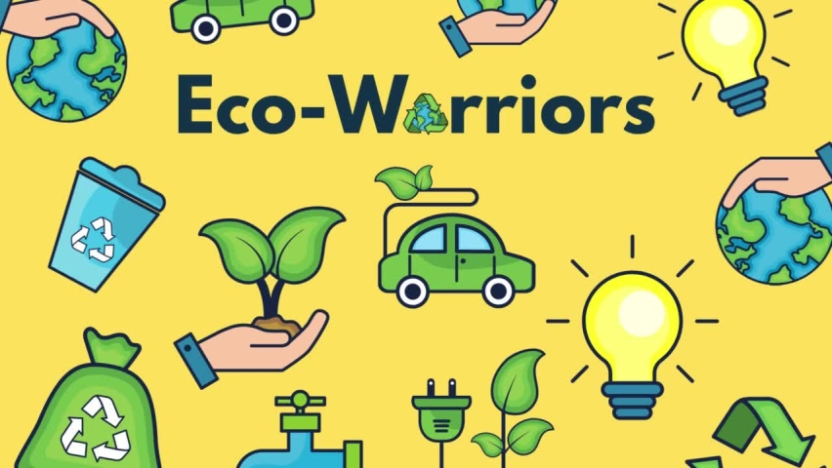

Maths

**Number and Place Value:Numbers to 40**

Pupils will be exploring numbers to 40 in a variety of ways. The beginning of the chapter focuses on counting to 40 in different ways and writing numbers to 40. As the sequence progresses, pupils are comparing numbers and looking at number patterns.

National Curriculum Objective:

Pupils to count to and across 40, forwards and backwards, beginning with 0 or 1, or from any given number. They should count, read and write numbers to 40 in numerals; count in multiples of 2s, 5s and 10s. Pupils to be given a number, identify 1 more and 1 less and identify and represent numbers using objects and pictorial representations including the number line, and use the language of: equal to, more than, less than (fewer), most, least.

**Geometry- Position and Direction: Positions**

Pupils will gain an understanding of positional language, as well as directional language for left and right.

National Curriculum Objective:

Pupils to describe position, direction and movement, including whole, half, quarter and three-quarter turns.

**Measurements: Length and Height**

Pupils will compare lengths and describe whether something is taller, shorter or longer. They will learn how to measure two objects for comparison using items and body parts, before moving on to measuring using a ruler.

National Curriculum Objective:

Pupils to compare, describe and solve practical problems for lengths and heights [for example, long/short, longer/shorter, tall/short, double/half]

English

**Fiction- Adventure Story**

The Secret of the Black Rock by Joe Stanton

**Non- Fiction- Instruction Writing**

How to save a Whale

**Poetry: Poems about animals**

write a sequence of sentences to form short narratives, including personal experiences and those of others (real or fictional)

use the joining word and

use simple past and present verbs mostly accurately

use capital letters and full stops to demarcate some sentences accurately

use capital letters for proper nouns use question marks to demarcate some sentences

use exclamation marks to demarcate some sentences

use their Phase 2, Phase 3, Phase 4 and Phase 5 phonic knowledge to write words in ways which match their spoken sounds – many being spelt correctly and others being phonetically plausible

add the suffixes –ing, -ed

Spell most Year 1 common exception words taught

form many lower case and capital letters accurately

write with many letters accurate in shape and size, including capital letters and digits use spacing between words

re-read writing to check that it makes sense

read aloud their writing to each other and the teacher

**Eco- Warriors**



History

**The Invention of Plastic**

Pupils should be taught about changes within living memory. Where appropriate, these should be used to reveal aspects of change in national life Skills covered:

**Skills Covered:**

Recognise the difference between past and present in their own and others lives

Use stories to distinguish between fact and fiction

Find answers to simple questions about the past from sources of information e.g. artefacts

Communicate their knowledge through:

Discussion….

Drawing pictures…

Drama/role play.. Writing

Science

**Animals including Humans/ Seasonal Changes**

National Curriculum Objective:

Children will identify and name a variety of common animals including fish, amphibians, reptiles, birds and mammals They will identify and name a variety of common animals that are carnivores, herbivores and omnivores Children to describe and compare the structure of a variety of common animals (fish, amphibians, reptiles, birds and mammals including pets). They will identify, name, draw and label the basic parts of the human body and say which part of the body is associated with each sense.

Pupils should be taught to ide observe changes across the four seasons and describe weather associated with the seasons and how day length varies.

Skills covered:

**Animals Including Humans**

Identify and name a variety of common animals including fish, amphibians, reptiles, birds and mammals.

Identify and name a variety of common animals that are carnivores, herbivores and omnivores.

Describe and compare the structure of a variety of common animals (fish, amphibians, reptiles, birds and mammals, including pets).

Identify, name, draw and label the basic parts of the human body and say which part of the body is associated with each sense.

Describe the basic needs of animals, including humans, for survival (water, food and air).

Describe the importance for humans of exercise, eating the right amounts of different types of food, and hygiene.

**Seasonal Changes**

Observe changes across the four seasons.





PE

**Games- (Send, Return, Net and Wall)**

National Curriculum Objective:

Pupils should develop fundamental movement skills, become increasingly competent and confident and access a broad range of opportunities to extend their agility, balance and coordination, individually and with others. They should be able to engage in competitive (both against self and against others) and co-operative physical activities, in a range of increasingly challenging situations.

Master basic movements including running, jumping, throwing and catching, as well as developing balance, agility and co-ordination, and begin to apply these in a range of activities.

Participate in team games, developing simple tactics for attacking and defending.

Skills Covered:

Can describe how they worked with their partner to send and receive

Confident to explore different actions such as hitting other types of targets

With some accuracy and sensitivity, feed ball to a partner for them to hit

Score points against opposition over a line/net

Chase, stop and control balls and other objects such as beanbags and hoops

Use coordination and agility to keep rallies going in pairs and small groups

Track balls and other equipment sent to them, moving in line with the ball to collect or return

Work with a partner to send and return an object and play a simple rally

Recognise your actions impact others, e.g. feeding a ball accurately and at the correct pace.

Art

**Seascape in Van Gogh’s style (paintbrush techniques)**

Children to learn about the work of a range of artists, craft makers and designers, describing the differences and similarities between different practices and disciplines, and making links to their own work. They will use drawing, painting and sculpture to develop and share their ideas, experiences and imagination

Skills covered:

Work on a range of scales e.g. large brush on large paper etc.

To use different sizes of paintbrushes and different paintbrush strokes

Ask and answer questions about the starting points for their work and the processes they have used.

Develop their ideas.

Explore the differences and similarities within the work of artists, craftspeople and designers in different times and cultures.

Create images from imagination, experience or observation.

Mix and match colours to artefacts and objects.

Mix a range of secondary colours, shades and tones.



Music

**Round and Round**

Pupils should be taught to use their voices expressively and creatively by singing songs and speaking chants and rhymes.They will play tuned and untuned instruments musically.Pupils will listen with concentration and understanding to a range of high-quality live and recorded music. Pupils will experiment with, create, select and combine sounds using the inter-related dimensions of music.

**Singing**

Begin with simple songs with a very small range, mi-so (e.g. Hello, how are You),

and then slightly wider (e.g. Bounce High, Bounce Low). Include pentatonic songs

(e.g. Dr Knickerbocker).

**Listening**

Listening to recorded and live performances.

**Composing**

Understand the difference between creating a rhythm pattern and a pitch pattern.

**Musicianship**

**Pulse/beat**

Use body percussion, (e.g. clapping, tapping, walking) and classroom percussion

(shakers, sticks and blocks, etc.), playing repeated rhythm patterns (ostinati) and

short, pitched patterns on tuned instruments (e.g. glockenspiels or chime bars) to

maintain a steady beat

**Rhythm**

Perform short repeating rhythm patterns (ostinati) while keeping in time with a

steady beat.

**Pitch**

Explore percussion sounds to enhance storytelling, e.g.

ascending xylophone notes to suggest Jack climbing the beanstalk,

quiet sounds created on a rain stick/ shaker to depict a shower,

regular strong beats played on a drum to replicate menacing footsteps

**Evaluating and appraising**

Choose sounds and instruments carefully and make improvements to their own and others’ work.

.

Computing

**Data Hnadling**

To use technology purposefully to create, organise, store, manipulate and retrieve digital content

Use technology safely and respectfully, keeping personal information private; identify where to go for help and support when they have concerns about content or contact on the internet or other online technologies.

Skills covered:

Sort and classify objects based on their properties.

Create a simple pictogram.

Create a pictogram and to interpret the data it represents.

Change the data independently in a pictogram and comment on the effects of the changes.



PSHCE

**Appreciate**

Pupils to understand what appreciate means, what types of things we appreciate, and how we show appreciation.Pupils to know that you can appreciate others, experiences and themselves and not just material things. They will be able to say the categories on the Wheel of Gratitude.The should know how to develop an Attitude of Gratitude. They will learn that showing gratitude makes them feel good; when we make someone feel good, it makes us feel good too.They will look at how Happy Breathing exercises help to remind us to appreciate the things we might forget.They will do this by practising giving gratitude over and over again, our brains will improve at appreciating things and people. This is called Neuroplasticity.Pupils to know that when we give and receive gratitude, it makes Team H-A- P happy, and they can work well together.

Story Project

Morris the Mankiest Monster by Giles Andreae

Pupils to tell you how some diseases spread and can be controlled.They can tell you the importance of personal hygiene and of brushing their teeth in the morning and evening. Pupils can tell the consequences of not making the right choices to live a healthy lifestyle.They can describe the right choices to make to live a healthy lifestyle (e.g. food, rest, exercise, brushing teeth, water)

Skills covered:

The risks associated with an inactive lifestyle (including obesity).

How and when to seek support including which adults to speak to in school if they are worried about their health.

Simple hygiene routines that can stop germs from spreading.

About what keeping healthy means, different ways to keep healthy.

About dental health and the benefits of good oral hygiene and dental flossing, including

regular check-ups at the dentist.

About personal hygiene and germs including bacteria, viruses, how they are spread and treated, and the importance of handwashing.



DT

**Making a Healthy Meal**

|  |
| --- |
| Pupils to design purposeful, functional, appealing products for themselves and other users based on design criteria. Pupils will generate, develop, model and communicate their ideas through talking, drawing, templates, mock-ups and, where appropriate, information and communication technology. Pupils to select from and use a range of tools and equipment to perform practical tasks [for example, cutting, shaping, joining and finishing]. They will select from and use a wide range of materials and components, including construction materials, textiles and ingredients, according to their characteristics. Pupils will explore and evaluate a range of existing products. They will evaluate their ideas and products against design criteria.Pupils to use the basic principles of a healthy and varied diet to prepare dishes. Pupils to understand where food comes from |

Skills Covered:

Developing, planning and communicating ideas.

Suggest ideas and explain what they are going to do

Model their ideas in card and paper

Working with tools, equipment, materials and components to make quality products (inc-food)

Make their design using appropriate techniques

With help measure, mark out, cut and shape a range of materials

Use tools e.g. scissors and a hole punch safely

Assemble, join and combine materials and components together using a variety of temporary methods e.g. glues or masking tape

Select and use appropriate fruit and vegetables, processes and tools

Evaluate their product by discussing how well it works in relation to the purpose

Evaluate their product by asking questions about what they have made and how they have gone about it.

RE

**Easter- Plasm Sunday**

|  |
| --- |
| Recall parts of the Easter story.  Recognise some symbols in the story.  Start to show understanding that Jesus is special  to Christians and say why |