**Science - Year 6**

Summer Term – Evolution and inheritance

Living things and their habitats

**Science links**

**Evolution**

Understand that animals, including humans, have offspring which grow into adults (Y2)

Habitats can change in many ways (Y2)

Fossils are the remains of traces of plants and animals that lived long ago (Y3)

Recognise that environments can change and that this can sometimes pose dangers and have an impact on living things (Y4)

**Living things and their habitats**

Recognise that living things can be grouped in a variety of ways (Y4)

Explore and use classification keys to help group, identify and name a variety of living things in their local and wider environment (Y4)

**English links:**

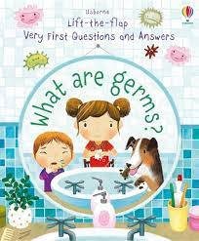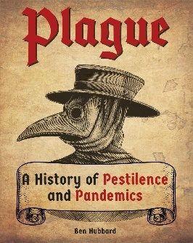



Experiences