**Science - Year 4**

Spring Term – Electricity

Living things and their habitats

**Geography links:**

Renewable energy sources produce less pollution which helps to protect the environment (Y3)

Renewable energy provides us with cleaner air and water (Y3)

**Science links**

**Electricity**

Objects are made from materials such as wood, fabric, glass, metal, cardboard, plastic or clay (Y1)

Compare and group together a variety of everyday materials (Y3)

**Living things and their habitats**

Identify and name a variety of common animals that are carnivores, herbivores and omnivores (Y1)

Identify and name a variety of common animals including fish, amphibians, reptiles, birds and mammals (Y1)

Explore and compare differences between things that are living, dead and things that have never been alive (Y3)

Identify that most living things live in habitats to which they are suited and describe how different habitats provide for the basic needs of different kinds of animals and plants and how they depend on each other (Y3)

A habitat must provide food, shelter, water and space (Y3)

Habitats can change in many ways (Y3)

**English links:**

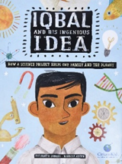



Sustainable development goals