**Science - Year 5**

Spring Term – Forces

Animals including humans

**DT links**

A lever moves in a curved motion (Y1)

A lever moves on a pivot (Y1)

A lever mechanism can have multiple pivots (Y3)

**Science links**

**Forces**

Forces are things that allow the movement of all things around us (Y3)

Compare how things move on different surfaces (Y3)

Notice that some forces need contact between two objects, but magnetic forces can act at a distance (Y3)

**Animals including humans**

Understand that animals, including humans, have offspring which grow into adults (Y2)

**English links:**

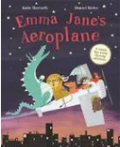





Experiences

