**Science - Year 3**

Autumn Term – Rocks

Plants

**DT links**

**Plants:**

A fruit is a food that grows on plants and has a seed (Y1)

A vegetable is a food that grows on plants but doesn’t have seeds (Y1)

Seeds come from the inside of flowers and fruits (Y2)

Oats are the edible seed of oat grass (Y2)

Seeds are a good source of protein (Y2)

**Science links**

**Rocks:**

Compare and group together a variety of everyday materials on the basis of their simple physical properties (Y2)

Identify and compare the suitability of a variety of everyday materials including wood, metal, plastic, glass, brick, rock, paper and cardboard for particular uses (Y2)

**Plants:**

Find out and describe how plants need water, light and a suitable temperature to grow and stay healthy (Y2)

Flowers are made up of roots, stems, leaves and flowers (Y1)

Identify and describe the basic structure of a variety of common flowering plants; including trees (Y2)

**English links:**

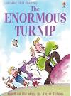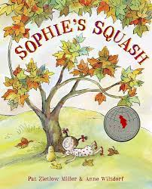



**Geography links**

**Plants:**

The countries closer to the equator are warmer and the countries further away are the coldest (Y1)

Experiences

