**Science - Year 5**

Summer Term – Properties and changes of materials

Living things and their habitats

**DT links**

**Properties and changes of materials**

Year 2 – Make Yorkshire puddings *(Look and cook primary school programme*)

Year 4 – Make cupcakes (*Look and cook primary schools programme*)

**Science links**

**Properties and changes of materials**

Compare and group together everyday materials (Y3)

Matter is another word for the stuff things are made of (Y4)

Everything falls into one of three categories: solid, liquid or gas (Y4)

Materials can change from one state of matter to another through freezing and melting (Y4)

**Living things and their habitats**

Understand that animals, including humans, have offspring which grow into adults (Y2)

Explore the part that flowers play in the life cycle of flowering plants, including pollination, seed formation and seed dispersal (Y3)

**English links:**

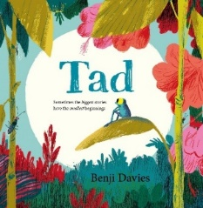

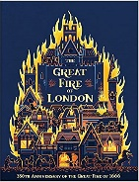

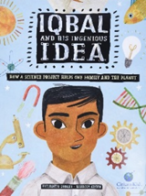

Experiences