**Science - Year 6**

Spring Term – Electricity

**DT links**

Make a torch (Y4)

An electric switch is used to control the flow of an electric current (Y4)

If the switch is allowing the current to flow, the electric item will be on (Y4)

If it is not allowing it to flow, the electric item will be off (Y4)

To make a switch, we need to use materials which are conductors so that the electricity will pass through (Y4)

**Science links**

Electricity is an energy. This energy can be used to power electrical items (Y4)

Electricity can only travel if there is a complete circuit (Y4)

A complete circuit is made up of different components – batteries (or cell), wires and bulbs, buzzers or motors (Y4)

Construct a simple series electrical circuit, identifying and naming its basic parts, including cells, wires, bulbs, switches and buzzers Identify whether or not a lamp will light in a simple series circuit, based on whether or not the lamp is part of a complete loop with a battery (Y4)

Recognise that a switch opens and closes a circuit and associate this with whether or not a lamp lights in a simple series circuit (Y4)

Recognise some common conductors and insulators, and associate metals with being good conductors (Y4)

**English links:**

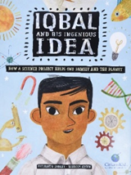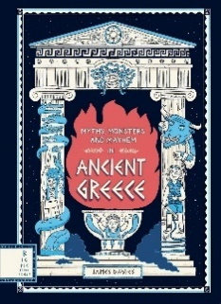

**Geography links**

Renewable energy sources produce less pollution which helps to protect the environment (Y3)

Renewable energy provides us with cleaner air and water (Y3)



Experiences