**Science - Year 2**

Spring Term – Materials

Plants

**Science links**

**Materials:**

Distinguish between an object and the material from which it is made (Y1)

Identify and name a variety of everyday materials including wood, plastic, glass, metal, water and rock (Y1)

Describe the simple physical properties of a variety of everyday materials (Y1)

**Plants:**

Plants need water, nutrients and sunlight to grow (Y1)

Identify and describe the basic structure of a variety of common flowering plants; including trees (Y1)

Spring is the season when plants start to grow again (Y1)

**History links**

**Materials:**

A plastic is a kind of material that is made by people and can be formed into almost any shape (Y1)

Most plastics are strong, long-lasting, and lightweight (Y1)

Most plastics are made from chemicals that come from petroleum (oil), natural gas, or coal (Y1)

Plastics can be made into almost any shape by heating them at a high temperature (Y1)

In 1869 John Wesley Hyatt, a U.S. inventor, made the first plastic (Y1)

Plastics are very useful, but they can also cause many problems for the environment if they end up in the oceans (Y1)

Items made out of plastic do not break down and take up room in landfill (Y1)

**English links:**

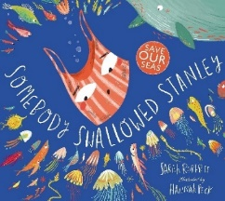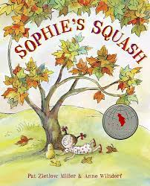

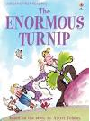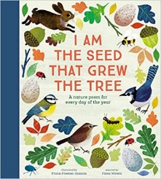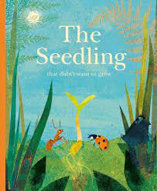

Experiences