**Science - Year 2**

Autumn Term – Animals Including Humans

Plants

**DT links**

**Animals including humans:**

Eating healthily supports people to have more energy (Y1)

**Plants:**

A fruit is a food that grows on plants and has a seed (Y1)

A vegetable is a food that grows on plants but doesn’t have a seed (Y1)

**Science links**

**Animals including humans:**

Exercising is good for humans (Y1)

Identify and name a variety of common animals including fish, amphibians, reptiles, birds and mammals (Y1)

Identify and name a variety of common animals that are carnivores, herbivores and omnivores (Y1)

**Plants:**

Plants need water, nutrients and sunlight to grow (Y1)

Identify and describe the basic structure of a variety of common flowering plants; including trees (Y1)

Identify and name a variety of common wild and garden plants, including deciduous and evergreen tress (Y1)

Spring is the season when plants start to grow again (Y1)

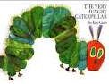**English Texts:**

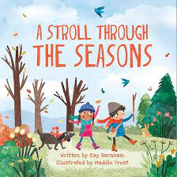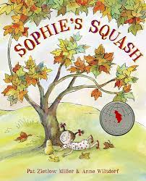

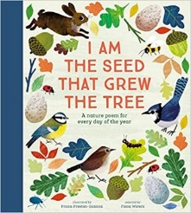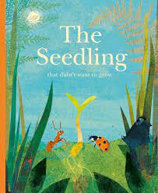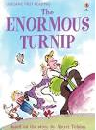



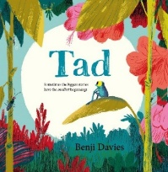

Experiences